*As a citizen we should fear ourselves—freedom has been introduced of our sexual disposition.* | *Civilization is only good behavior.*

# How the Judeo-Christian System Influences Civilization (Part 1) [1]

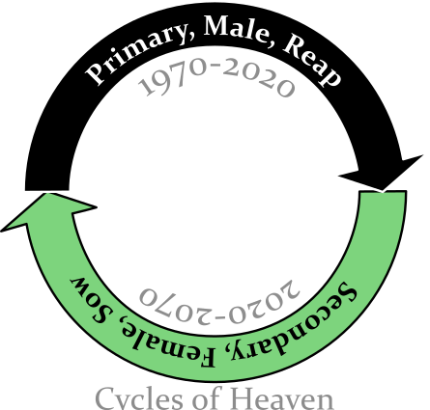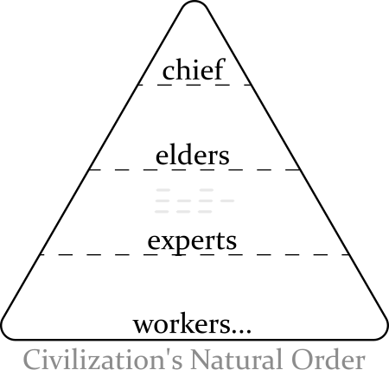Civilization began as a natural order. When the Judeo-Christian system started it upended it entirely. Civilization moved from evolution of a community to salvation of an individual through joining a secret, predesigned system (those that learn the details of the system get the rewards). Long ago the system started from male dominion (dynasties, i.e. fortunate people rewarding others fortunate) and got secreted by the Jews. Today the Jews implement it by rewarding *reaping* acts for an era of fifty years (i.e. taking—usually men). In this era the sins[2] become so numerous, the reapers, the Jews, the first group, the political left, become so profitted, so anchored in their thinking, that they draw the hostility of a second group of people. For the next fifty years the Jews tolerate/reward[3] *sowing* acts (making things grow/giving) **to deal with the resistance** (it affects women, their protected, men of lesser fortune—the political right). The entire system is kept silent through all of time. By the silence, alternating support, and by intent much confusion is caused to people outside the first group. This can get people in the second group to occasionally call an all-out *war* against the Jews. Being so stimulated/excited the Jews are little deterred by the second group’s frustration and the second group eventually caves in to get recognition and begins doing similar behavior. This behavior, these sins, the Jews reward with better inclusion—they perpetuate the system. The right is allied/associated/complicit to the left in a number of ways: first, they defer authority most of the the time (by number [12,42] and behavior); two, they can become so upset with the Jews that the focus is taken from those that need help the most (the third group, the people with little knowledge of the first group, or who are intentionally left behind); third, they accept answers from the Jews in how they use the Hebrew Code that turn out to *discriminate* against the third group (the second group’s knowledge is usually sparse and often incorrect); four, they keep the system largely silent, ~~amoungst other sins~~[4]. The Christian church (a succession of the second group) largely practices their beliefs with spiritual principles but is built upon a female leadership (formed with the New Testament) which gets safety with the Jews by forfeiting things, particularly people. The Jew maintain the system like a vital job. From it they get: physical protection (in the first fifty years), trust from the third group who they give much free attention to, and through it all authority and wealth. Their definition of it is literally *heaven*. ~~Any person that uses the system is likelier to have a successful life and likelier to keep heaven silent.~~ I have yet to find anyone who has any sufficient overview of what is happening. This system forces much of the social construct of the world.

* (gets them “saved”)
* –despite the right’s ill recognition of the impact of the sin and often thinking it helpful.
* The Jews administrate over most of the system (i.e. have created a lot of the right’s power [through the code, etc.], completely ignorant to the right). The right has visceralness.

## Who I Am

I am a person given as a sacrifice at an early age. By the political right giving the Jews sacrifices the right has been able to get things from them. Some of those sacrifices are large. I am one of those people. By doing sin to me some things were gotten that helped civilization as a whole. There are a good number of sins and they affect my mind and behavior. ~~People have learned to treat me differently to get protection themselves.~~ This has been come done so much that it has removed me from civilization. I learned what I know now by accepting truths that were hard; I had to look at improbable answers to try to survive because life became too impossible to live reasonably anymore. There are other people are included besides me, we would appreciate any help.

## Research Sources

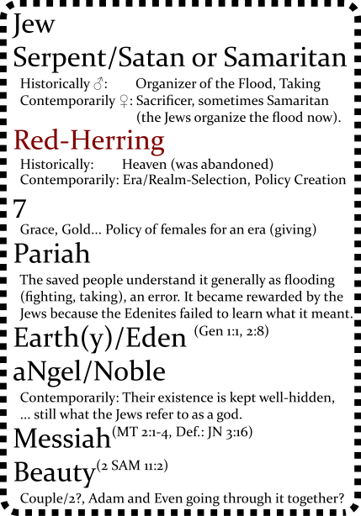The research for this paper is generally from the Bible. The Bible, the most read book in the world, is where the Jews and Christian leaders document their intent—institutions that have been around awhile usually provide a plan. Both the Jews and the Christians have described their plans in their Testaments. The Bible is audacious and often graphic to hide meanings that can only be tolerated by those who have abundant health (from supernatural safety). Getting past these adversion one can discover the intent of the Bible and how it influences civilization. Those that are a part of the system project the Testaments as fair declarations with civilization. It falls below that standard by leaving out a lot of initial history, by being intentionally cryptic, and trying repulse interest[5].

The Jews have spent much time refining the Bible because their system has been so profitable to them. A few things to know. The Jews prioritize conveying their methodology over historical integrity. The big skew is the Bible being written revisionistically[6], backwritten, to make newer rules apply throughout. Another thing to know it that the beginning of the Bible is full of important scattered details (because so much history is missing), and the Bible is sortof the second group’s of the story (except for Genesis 1) the story of societal sliding and sacrifices.

* The Bible does make sense.

## Hebrew Code

The Hebrew people use a code to share secrets with. It is hidden within ordinary language. The base meanings have *absolute* definitions.

## The Secret of Heaven

(The “Secret of Heaven” is my title. As far as I know it has been defined only here. I consider it an appropriate title to describe this occurance in history.) The “Secret of Heaven” comes from before the Bible was written. The chance of understanding the Bible absent of knowing the “Secret of Heaven” is very small. How the “Secret of Heaven” was formed is part speculation, it is derived from my experience and my limited reading of *History of Egypt, Chaldea, Syria, Babylonia, and Assyria, Volume 3*[7].

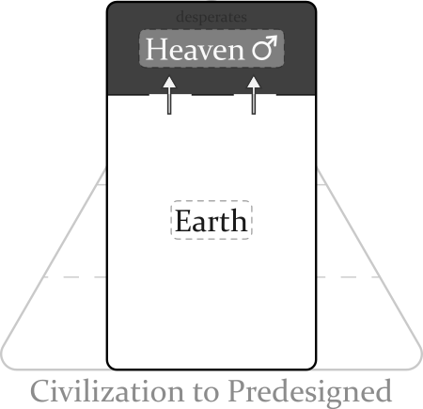The Secret of Heaven started because of an environmental threat. The area the system started in was the Tigris-Euphrates rivers of present-day Iraq around 4100 years ago. This is where Abraham came from (Gen 11:28-31). The area is surrounded by a lot of desert. Surviving in the area was risky at times (droughts, distance from safe land…). It could create fortunate men and desperate men, some rich and others fighting for their life. The residents became afraid of the desperate men’s mood when their behavior became visceral[8]. Someone doing better (the ancient Hebrew) thought a desperate person particularly dangerous but decided to reward him for personal protection. He kept it silent because the desperate person’s behavior effected others adversely. The desperate person felt a life-debt and protected his underwriter even beyond ethical boundaries. The ancient Hebrew decided to keep on rewarding him for these desperate acts. He felt very *intelligent*. The desperate man became more *visceral*—it grew to a feeling of being open-bounded, built to narcissism, then he became strong enough to define what “good”[9] was, lastly an insularity can build where abnormal experiences are required for him to find things interesting. These were men to be feared. Both men prospered from this, a feeling of obtaining *free* began. Other men that were doing well began to catch on. Silently, it spread in the area. The relationship between *intelligent* man and *visceral* man formed a symbiotic bond that came to be known as the “Secret of Heaven”. The great Jewish two system was born. In Genesis 2 it **doubles** again.

Harsh land, a few fortunate. One rich, another fighting for his life. The rich man sees a desperate man **sin** (e.g. steal some seeds). He confronts him and decides it is dangerous to argue with someone who is trying to save his life. The rich man knowing that even his fortune can be effected by the environment says to himself, “This would be a great person to have on my side.” So, instead, he *rewards* him for the sin (e.g. allows him to use some irrigation water). Afterward, he decides to reward other sins of his as well (that can be gotten away with). The desperate man became big and powerful, someone to be feared. By rewarding him, the rich man was able to create policy. It turns out that supplementing the basic male trait (men liking taking) influenced male behavior in the area. This stimulated other fortunate men to reward likewise and an infestation of male-taking began. It lasted a long time.

## Bible Translation

**Genesis 1** *(Primary, Male-Policy, Reap)* Heaven originally was an all-male institution. It lasted a long time and Genesis 1 covers it all—in one giant swath. To the Hebrews, men by *taking*, for themselves, create good. A rewarded desperate-man *took* so much that the Hebrews refer to him as a “God”, “In the beginning *God* created the **heavens** and the **earth**” (Gen 1:1 NIV). Heaven was such an attraction it became systematic. A man would double a previous desperate man’s sin and change one facet of it: day/night, water/sky, land/sea, sun/moon, **man/nature**. The effect it had on nature was large. ••more “good and evil”[10] was done••

**Genesis 2** But men taking all the time and being completely secretive caused a serious problem: heaven became obvious. So the women (the wives… of the noble men) caused a stir.

**Genesis 2** *(Secondary, Female-Policy, Sow)* “By the **seventh** day God had finished the work… so on the **seventh** day he rested from all his work.” (Gen 2:2). Something is different here. Resting. Seventh. Genesis 2 starts off with the LORD ♀. Yep, *she*[11] contends the creator of plants, formed man. This doubling (Gen 2:5-7 from Gen 1:27-29) means there is a new leader in town. To the quick: there is a problem with the all-male heaven. Men reaping all the time causes a lot of butting heads… heaven becoming obvious. So a noble female (likely a wife of a god) sees how the mortal females have become desperate and talks to the serpent[12]. The idea she sold him on was: that they could take a desperate man’s wife and get her (Eve here) to enforce policy through him. The males had their chance and to make someone else do it provided better protection. He agreed… ~~found it hard to argue with the raw mortal energy~~. Adam, a sprouting male god, is controllable. The LORD grooms him, gives him a farm—it makes him feel confident like a god. Gives him a wife (finds someone willing to steer him). Adam and Eve were still of nature though “naked and they felt no shame”. Key word: **Eden** (2:8).

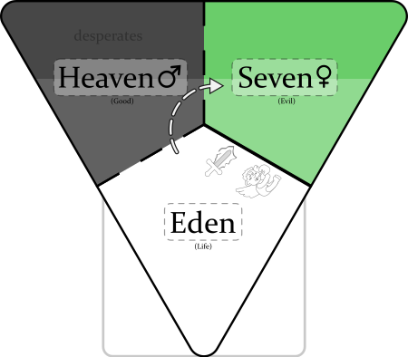**Genesis 3** *(~~Primary,~~ Secondary, Male-Female-Policy, Reap)* In ancient Hebrew history the power structure is thus: there are a bunch of Desperates/Nobles; their Rewarders who like to keep very silent (If I remember correctly they are represented as a single entity, who they called Ea, later Hea [which is how heaven got its name]); and the Nine who would be like a mayor today—he got to decide who the nobles were (by creating floods [selfish spats] when was told were necessary). So the serpent (very powerful at the time) who has already decided to try female-policy, tempts Eve into taking the fruit (the polar/opposite of what the female LORD is allowed to do… the great Jewish two system). A god enactment is done by Eve recognizing the tree to be “good for food and pleasing to the eye” (Genesis 3:6 doubles Genesis 2:9); she sins by partaking of the fruit to “be like God” and because it is “desirable for gaining wisdom”. She also gives some to Adam. They become above nature: “realized they were naked”. The woman LORD chews them out (double-talk [saying one thing buy meaning the opposite]: congratulates them): the serpent (praise be him for our nobility) is to be above everybody; the enmity between the serpent and the woman LORD really means that they will be good friends; the female gods (like Eve) will rule over their husbands; the man will enjoy life and be lazy (will probably represent us too [kind of had to as the male gods generally think that only men rule]), and Adam just a bumbling follower must be kept from returning to Eden (Gen 3:22), protected by “cherubim and flaming swords” (akin to sons and daughters of Genesis 6:2, people to be feared). ••“Gaining wisdom” is (hu)man over nature, intellect or **visceral-ness**, safety solely by thinking (with the predesigned system)—a luxury for any animal. The reaping renews again when Eve then Adam partake of the fruit. The Hebrews to keep prosperous the using of naive people, refer to the people of Eden almost silently. Key words: dust, dust, dust (14, 19).••

**Genesis 4** *(Secondary, Female, Sow)* Some people have created a female god. Eve is the “LORD” here. Cain, Abel, and Seth are probably associates of Eve rather than her kin (kin usually get heavenly inclusion). Cain and Abel try to bribe Eve with “fruits” and “fat-portions” so that they can get to heaven (fat-portions probably wins because it is something other than the fruit like of the tree of good and evil). “Do what is right (3:7)” means to win, and “sin is crouching at your door” means to be wary of nature, “you must rule over it”. The line that “Cain attacked his brother Abel and killed him” is a fooling, a trick. It says that those with Eve/LORD will emphasize the later definition (e.g. “brothers keeper”)[13]. She too curses her male subjects (doubles the action… takes out the cursing) and still gets to “save” them *from Eden* (Gen 3:14-19). She also gives Cain protection, “… anyone who kills Cain will suffer vengeance **seven** times over”. Cain followed the directive where the god before put “cherubim and a flaming sword” and went around to the “east of Eden” (to the new heaven on the right). Lamech doubles the seven because he sees the trick, but something happened before:

**Genesis 5** *(Some Rule Eden, Generally Female Policy)*: A time span of ten male rulers from Adam to Noah is defined. ~~The “E” is kept so silent that the reapers accept ENOSH as leader?!~~ When the females get their era back they put a reaper god there to rule… within female policy. Two more eras happen (Mahalalel and Jared) then Enoch rules in another male era (even more Edenish) and the reapers figure it out, “God took him [Enoch] away (Gen 5:25).” An Eden ruler Methuselah rules the female era, then the reapers put in a female-appointed god (Lamech). Then Noah comes, the avenging angel. Lamech proclaims that Noah is to restore god rule that Adam’s weak, female appointed rule, lost, “[Noah] will comfort us in the labor and painful toil of our hands caused by the ground the LORD has cursed (references Gen 3:17).”

**Genesis 6** *(She Said but a dual-power to restore heaven)*: Attack on Eden begins. God pronounces a dual-power, “a hundred and twenty years.” The “sons of God” (female leaders) sucked up the pride in their own god-ness and mated with the “daughters of humans” (desperate men, angels). This created Nephilim—people that are physical giants, knowing little borders, people to be feared—to create heaven again. The Lord (a female god here) is upset because civilization is co-operative and thoughtful (“wickedness… [and] evil” Gen 6:5) and wants to restore the gods to power. She uses Eden’s name (3,5,6) to set-up the exercising of god power, “The ark is to be *three* hundred cubits long, *fifty* cubits wide and *thirty* cubits high. (Gen 6:15).

**Genesis 7** *(He Said, Business, Partisanship)*: (The flood is rewarding, in synchronicity, a large number of *desperate* men to create "heaven on earth", partisanship, creating good and evil. [^flood].) The Lord found Noah “righteous” (godly) and he flooded the *earth*, put a*n*imals on the Ark, to restore the gods to power. More using Eden’s name for god power, “Noah was six hundred years old…”, etc.. ("The waters flooded the earth for a hundred and fifty days (Gen 6:24)" is used in modern times to denote yearly floods from to January 1 to May 31 (absent a leap year)).

* Double and get higher.
* When god’s behavior becomes extreme the Hebrews tell people to “Fear God”.
* The serpent encouraged selfishness.
* The Jews try to make their history look planned here, but the truth is since the Jews keep heaven [the great Jewish two system] always silent, a progressive confusion begins early on the second group. The confusion has created a path for people that start near-sighted and ignorant of complicity but become desperate—a staging heaven to Judaism.
* Became eventually: The women are going to flood too and do it better.
* This directive (Gen 3:22) will develop to: that to become a god a person must do a sin that is unforgivable within civilization to get “saved”… it keeps them silent.
* “friends (Job 2:11)”
* (narcisstic, desperate)
* it hides the flood
* the right: the enablers, the finger-waggers
* quotes as ” or ’ rather than ’ and ” ?!
* Verbatim Character in templates fix.
* favoring or divining?? divisive, partisian?
* first-group (that sometimes get identified as the Jews)
* plausible deniability
* follow/trick
* Since the Jews are responsible for the systems’s secrecy… There is only one system so everything the right does is false

## Things I Know About the Bible

* Jacob’s taking of Esau’s inheritence means: He took Esau’s leadership as first-born away. The older brother has greater experience, a better perspective from the jungle that he has chopped away. By Jacob flooding (one-ing), joining heaven he becomes the authority. He continues to antagonize Esau and is rewarded for it. From this antagonizing he get god-isms, Jew support mechanisms (e.g. burning the barn…) which he can dole out to people to get them saved. Jacob creates Israel this way, a female-led nation, a contender to Judah. Jacob the father of a nation. Esau gets lost in the wilderness—for possibly the rest of his life (I am surmising that even Jacob’s son Isaac may referring to Esau and being asked to sacrifice him). Left behind, a messiah. All saved people ignore him, laugh at him. He may die. I am the only person in history that may know this.
* Ruth is Bathsheeba
* Jesus is a conglomeration of messiah stories. They are meant to demonstrate the new “right” policy. It is likely most based on Paul who was likely the one given up as a baby. This sacrifice got the Jews very sexcited.

## 25 and 28 Please Please Tell Me Pyrite from the Jews (Rather Than The Saved Taking More…)

The second system starts because it is a manifestation of biology. Takers hardly cared about givers. The first group probably numbered it because they always want to be in control of everything and the right seems to be okay with “bad at math”. The second system usually defers priority, i.e. gives to the left first (12, 42…). Prioritizing seems to be tough for them: babies as sacrifices, looking pretty…. They already had their righteousnesses like 52 and 82. But being outside of the control group, “bad at math”.. they are left feeling, “How fair are we treated?” Still *wanting*. So when the Jews introduced 25 and 28 with the advent of the Christian Church[14] (it is hopeful for me to think it was them that did this) the right soaked them up disregardless whether: if it was fair (same number of protections [87, 72…] the left has); or if they even knew what they meant (another pretty ring… for me?). Complicity.



alt text

1. 00_2024-07-05 https://tinyurl.com/HJCR1 https://bit.ly/HJCSIC
2. Simply defined as being against nature.
3. I am still working on this but I think (at least by some) that the Jews are trying to run the whole gambit. I have evidence for example of the recent Jew floppings (Jerry Seinfeld “Unbounded”, Richard Dreyfus “Hollywood out to get Jews”, Kendrick losing to Drake)…
4. I’ll get to these later.
5. I refrain from calling the Judeo-Christian system a religion because the common definition of religion usually involves spirituality with an ethereal god or gods.
6. From [Wiktionary](https://en.wiktionary.org/wiki/revisionistic): […] changing some accepted doctrine or view of history.
7. [History of Egypt, Chaldea, Syria, Babylonia, and Assyria, Vol. 3](https://www.gutenberg.org/files/17323/17323-h/17323-h.htm). Interesting: the original flood story (skip to “Men in the mean time became wicked”) or on Librivox [Part 5](https://librivox.org/history-of-egypt-chaldea-syria-babylonia-and-assyria-vol-3-by-gaston-maspero/).
8. I am using the definition from *Merriam Webster*: dealing with crude or elemental emotions, EARTHY; and from *The American Heritage® Dictionary of the English Language, 5th Edition*. Being or arising from impulse or sudden emotion rather than from thought or deliberation.
9. The Bible defines this as the “knowledge of good and evil” (Genesis 2:9). Originally, it was only creating good, getting to choose what to support/favor (particularly people). I also like the term “divining”. Evil came later when people started to declassify others to get inclusion.
10. The Bible defines this as the “knowledge of good and evil” (Genesis 2:9). Originally, it was only creating good, getting to choose what to support/favor (particularly people). I also like the term “divining”. Evil came later when people started to declassify others to get inclusion.
11. Yes the Bible writers do constantly use the pronoun “he” throughsout the Bible.
12. Before the Bible the nine was the organizer of the nobility. He choose who the desperate men were and made sure they were rewarded. It builds to “the flood” later.
13. Using a Hebrew flood number/letter in the second term do get their angels somewhat excited… again defferential.
14. December 25 and the year of Jesus’s death.